i-Finance UAT Results — Credit Cards (App 202)
Automated UAT run · 12-Jun-2026 · Environment: http://localhost:8081 (dev-proxy → ADB PROD)
Executed by Claude (Playwright). Mirrors UAT_CC_12-Jun-2026-NN.xlsx — one section per workbook case, with the evidence screenshot captured at the verification moment. Personas: SYS_ADMIN, CC_ADMIN (NASER.ALKHAJA), card holder (SHAIKHA.ALSUWAIDI), no-card user (SHAIKHA.GALAMERI). The card limit changed by the lifecycle case was restored afterwards.

Summary
29 cases — PASS: 29
Area | Cases | Pass | Partial/Manual | Fail | Pass %
Access & Session | 3 | 3 | 0 | 0 | 100%
Dashboard | 2 | 2 | 0 | 0 | 100%
My Card | 4 | 4 | 0 | 0 | 100%
Card Requests | 6 | 6 | 0 | 0 | 100%
Replenishments | 5 | 5 | 0 | 0 | 100%
Approvals | 3 | 3 | 0 | 0 | 100%
Administration | 4 | 4 | 0 | 0 | 100%
Shell & Language | 2 | 2 | 0 | 0 | 100%

Access & Session

CC-ACC-01 — Entry from Admin
PASS · Shared session · 12s
Admin login → module switcher → CC opened logged-in with full SYS_ADMIN nav
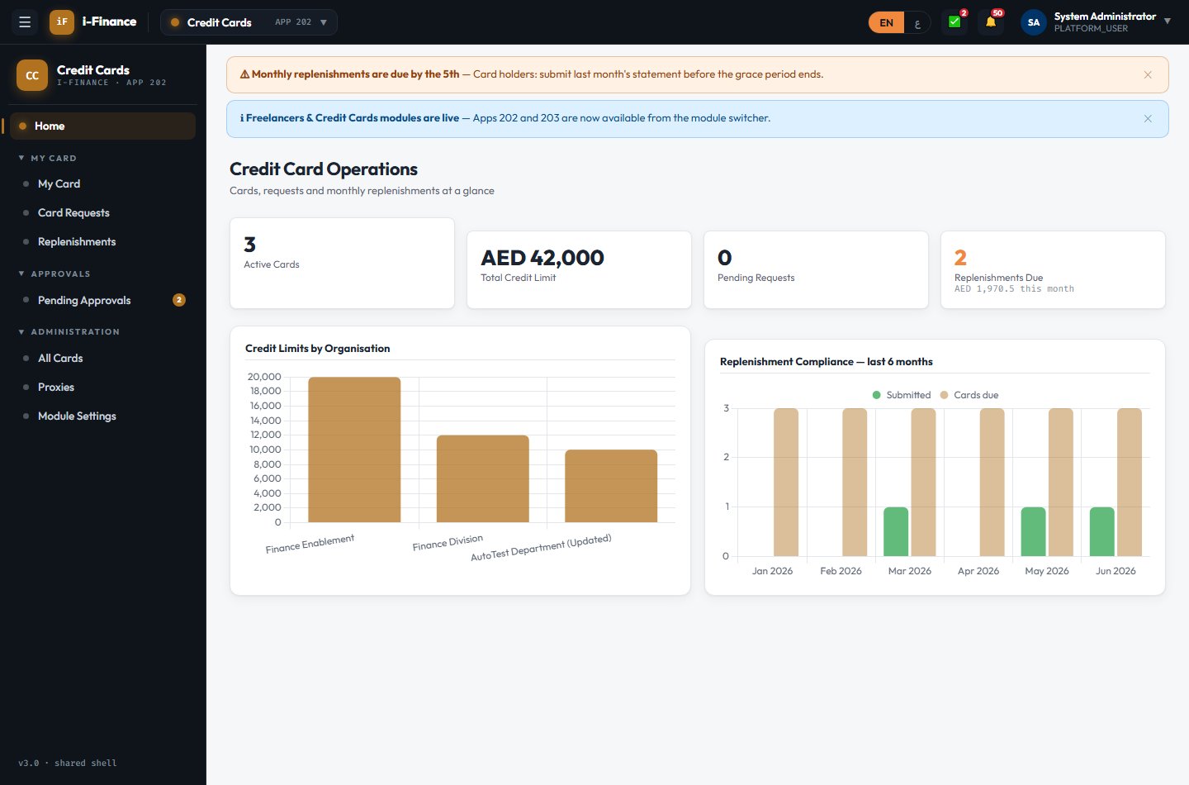
Evidence: CC-ACC-01.png

CC-ACC-02 — Direct open without login
PASS · No session · 8s
CC without a session redirected to the Admin portal login
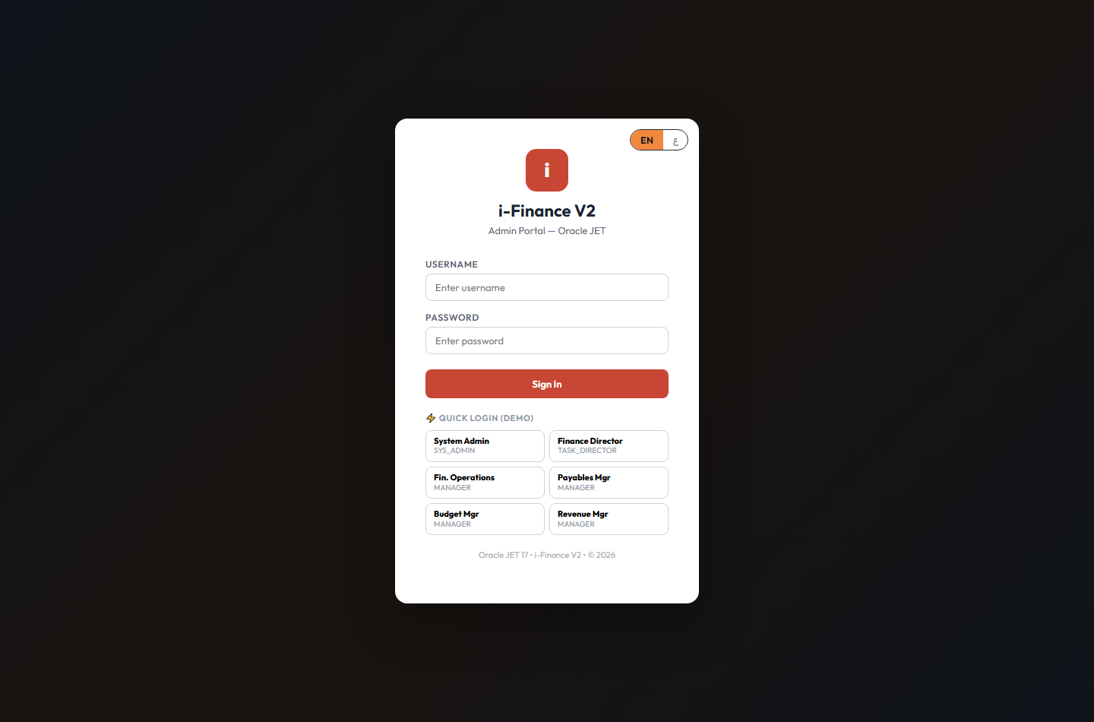
Evidence: CC-ACC-02.png

CC-ACC-03 — Admin menus
PASS · Role gating · 13s
Admin group (All Cards/Proxies/Module Settings) only for CC_ADMIN; holder has Approvals (MANAGER role dependent)
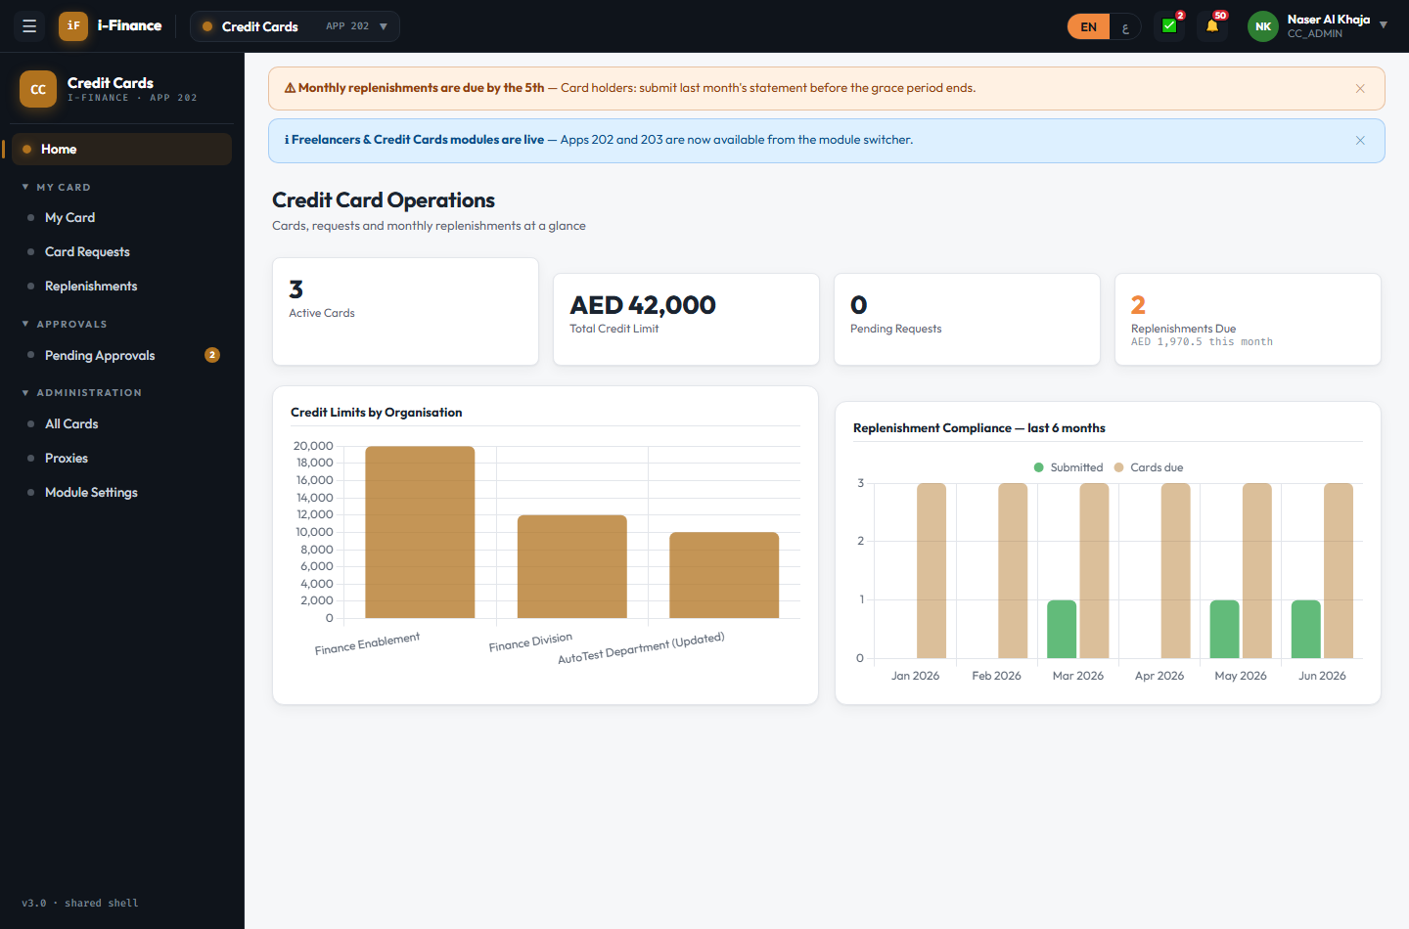
Evidence: CC-ACC-03.png

Dashboard

CC-DSH-01 — Cards show live numbers
PASS · Stats · 4s
Stat cards live: 3, AED 42,000, 0, 2

Evidence: CC-DSH-01.png

CC-DSH-02 — Limits + compliance
PASS · Charts · 5s
Limits-by-organisation + 6-month replenishment compliance charts rendered (2 canvases)

Evidence: CC-DSH-02.png

My Card

CC-CRD-01 — My card renders
PASS · Card visual · 3s
Card visual with masked number, holder, limit and ACTIVE status badge
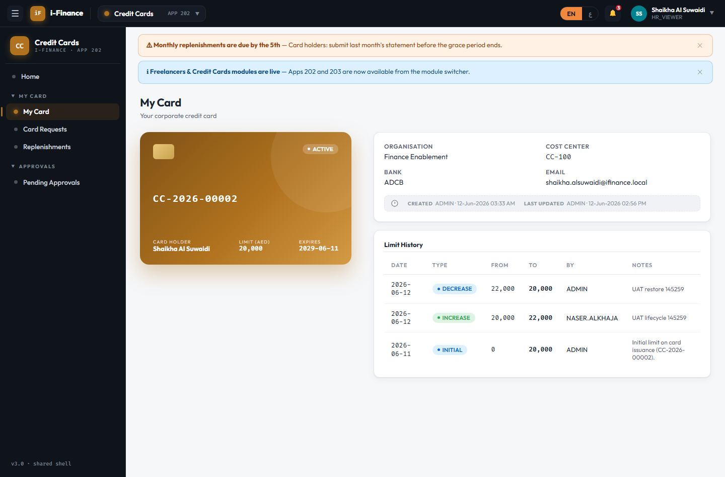
Evidence: CC-CRD-01.png

CC-CRD-02 — Timeline
PASS · Limit history · 3s
Limit history shows the registration INITIAL row (entries: DECREASE, INCREASE, INITIAL)

Evidence: CC-CRD-02.png

CC-CRD-03 — Replenishment due
PASS · Due banner · 4s
Current-month statement already exists (CCM-2026-06-00002) → banner correctly absent

Evidence: CC-CRD-03.png

CC-CRD-04 — Holder without card
PASS · No card · 8s
User without a card sees a friendly empty state offering a New Card request
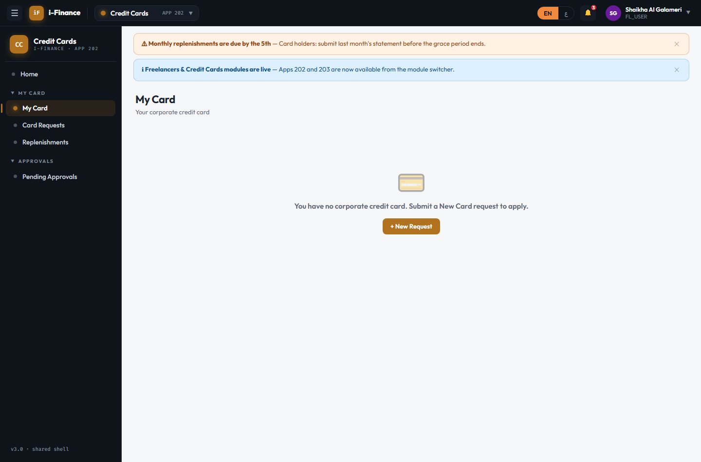
Evidence: CC-CRD-04.png

Card Requests

CC-REQ-01 — Type tiles
PASS · Wizard · 5s
5 request-type tiles (New/Increase/Decrease/Replacement/Close) on a 3-step wizard
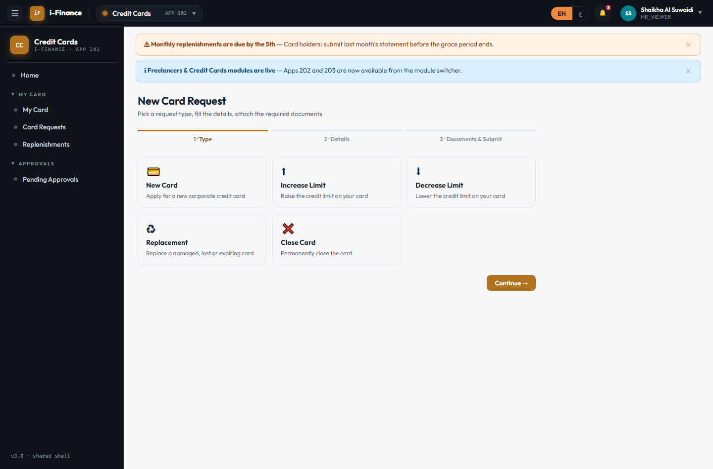
Evidence: CC-REQ-01.png

CC-REQ-02 — Full happy path
PASS · New card · 20s
CCR-2026-00012: NEW_CARD draft by SHAIKHA.GALAMERI, 4 documents uploaded, submitted to approval
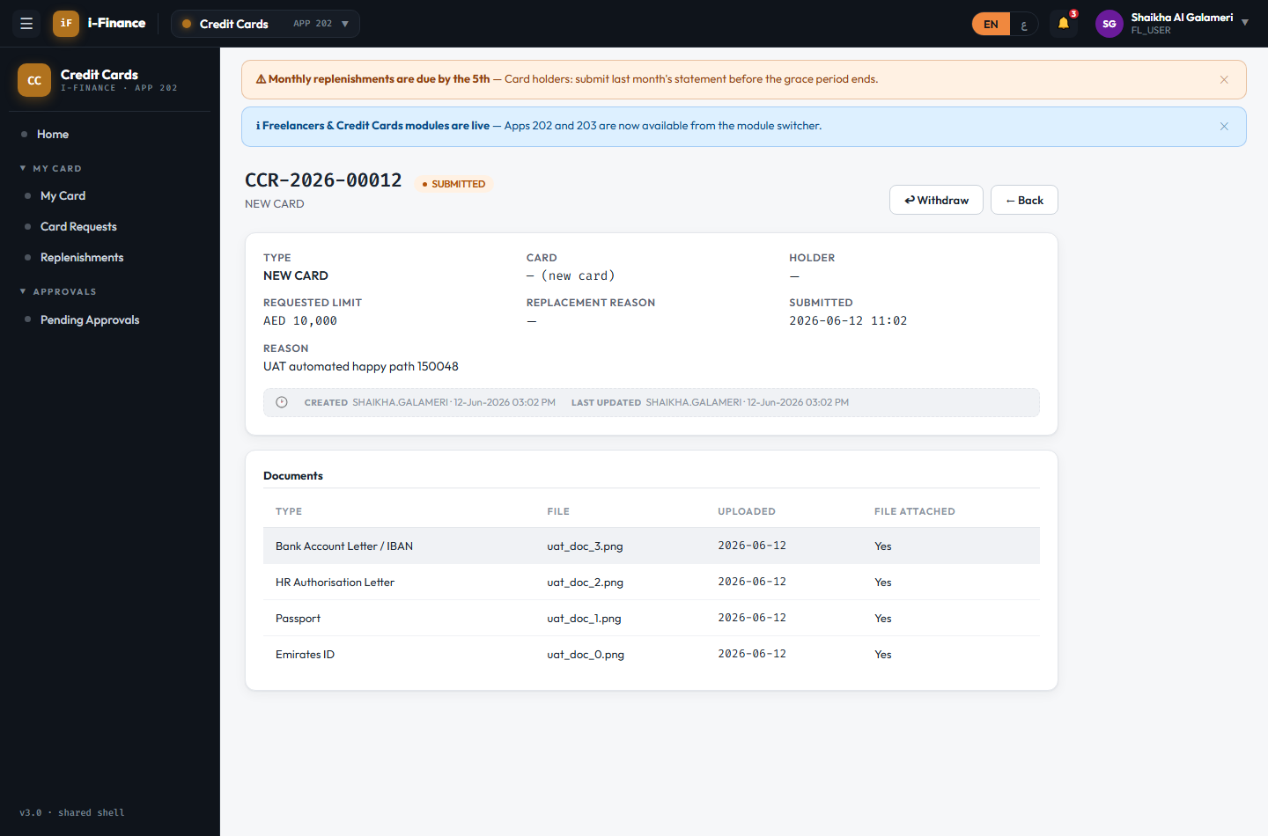
Evidence: CC-REQ-02.png

CC-REQ-03 — Mandatory docs enforced
PASS · Doc checklist · 10s
With 2 mandatory document(s) missing the Submit button stays disabled; saved as draft
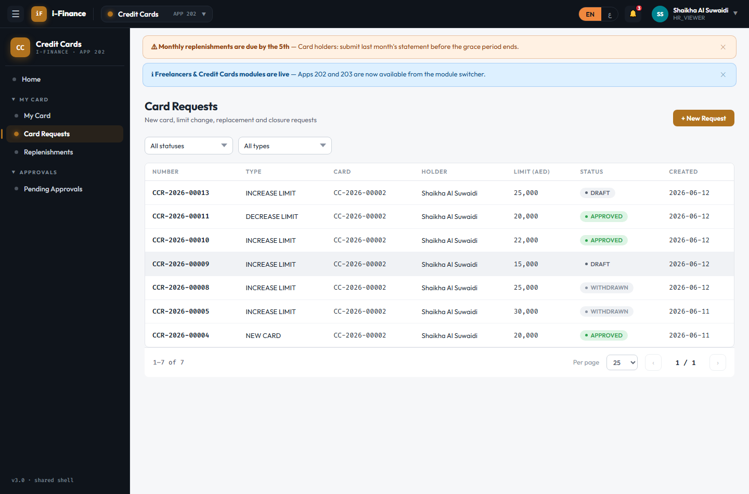
Evidence: CC-REQ-03.png

CC-REQ-04 — Validation
PASS · Increase limit · 15s
Blocked at submit: "⚠
ORA-20109: Requested limit must exceed the current limit (20000)." (requested 15000 < current 20000)
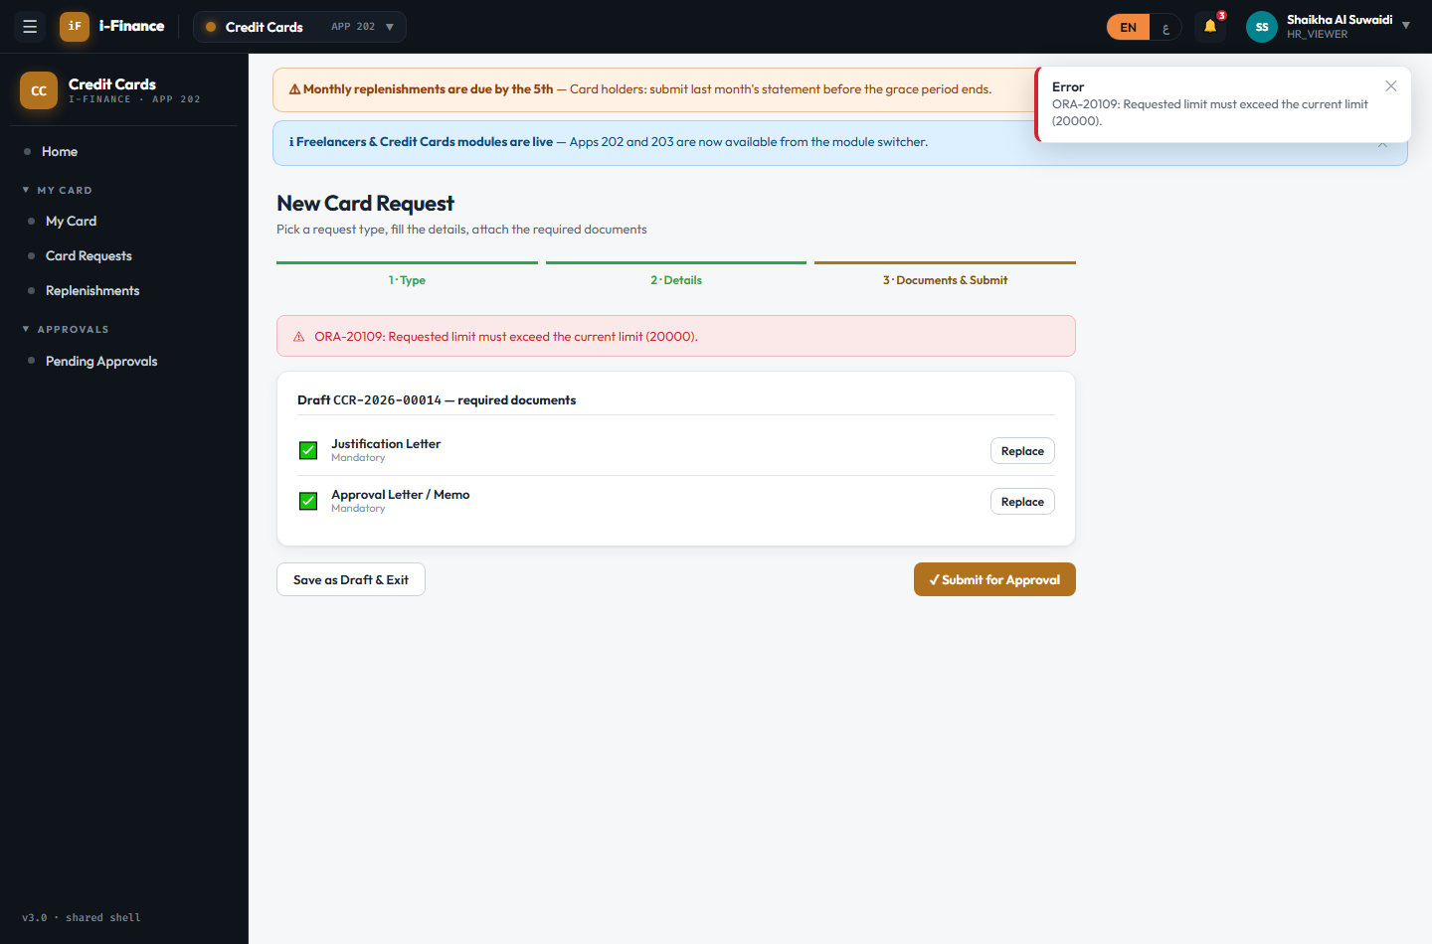
Evidence: CC-REQ-04.png

CC-REQ-05 — Pull back a submitted request
PASS · Withdraw · 10s
CCR-2026-00013 submitted then withdrawn; status WITHDRAWN and gone from the approver queue
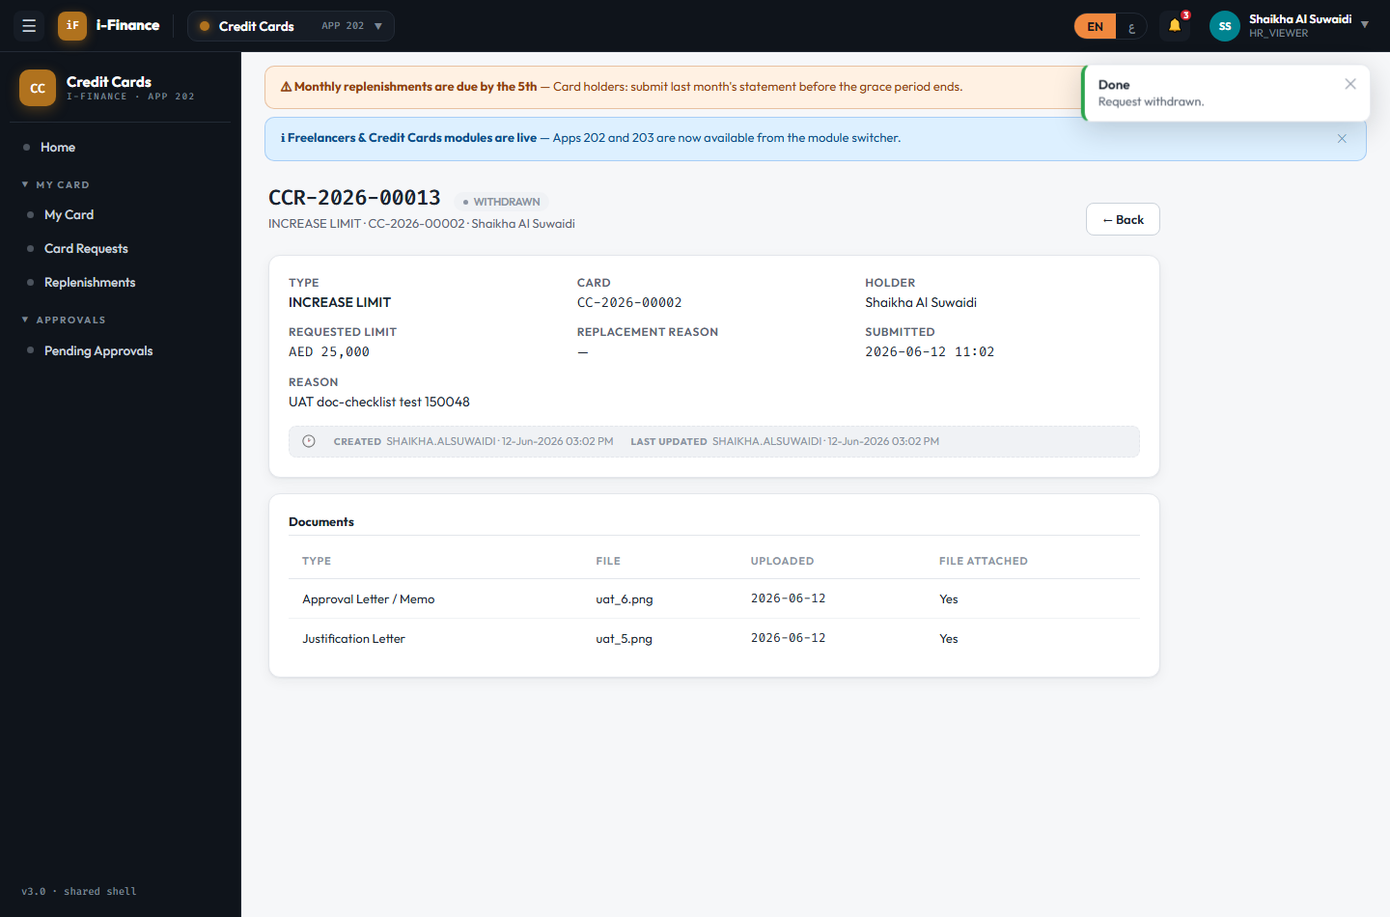
Evidence: CC-REQ-05.png

CC-REQ-06 — Request detail
PASS · Detail · 3s
Detail shows type, card, limits, reason, 4 document(s) and audit info

Evidence: CC-REQ-06.png

Replenishments

CC-RPL-01 — New monthly statement
PASS · Create · 14s
May 2026 duplicate blocked ("⚠
A replenishment for this card and period already exists"); CCM-2026-04-00005 draft created for Apr 2026
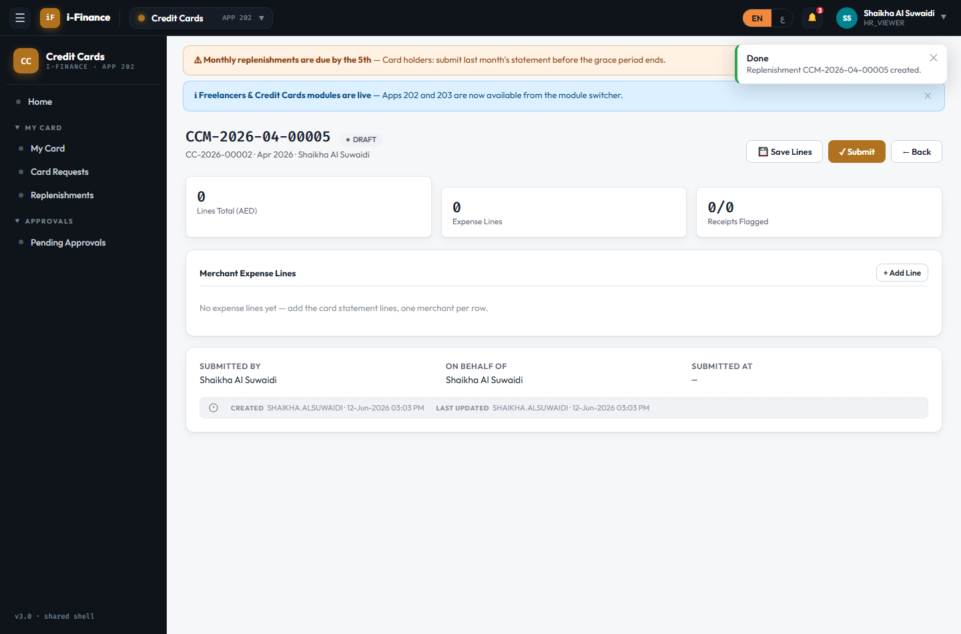
Evidence: CC-RPL-01.png

CC-RPL-02 — Merchant lines editor
PASS · Lines · 9s
3 merchant lines saved; running total AED 1,970.5; receipts flagged 3/3
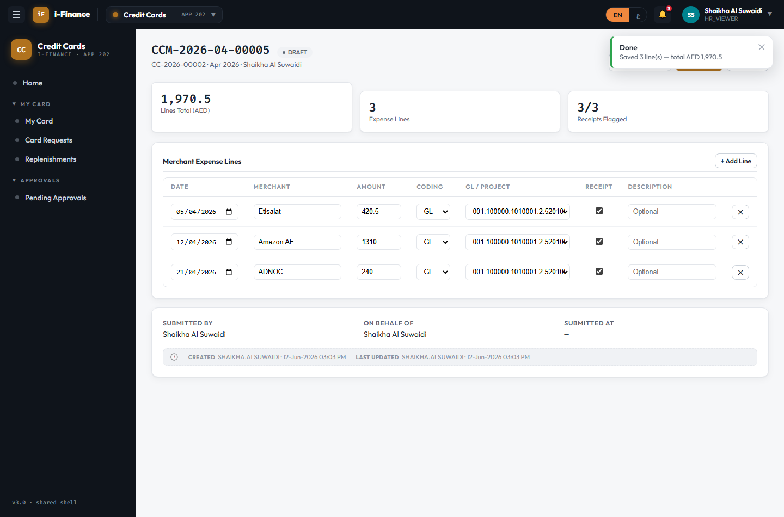
Evidence: CC-RPL-02.png

CC-RPL-03 — Line rules
PASS · Validation · 9s
Line without date/amount blocked with a per-line message; nothing saved after removal
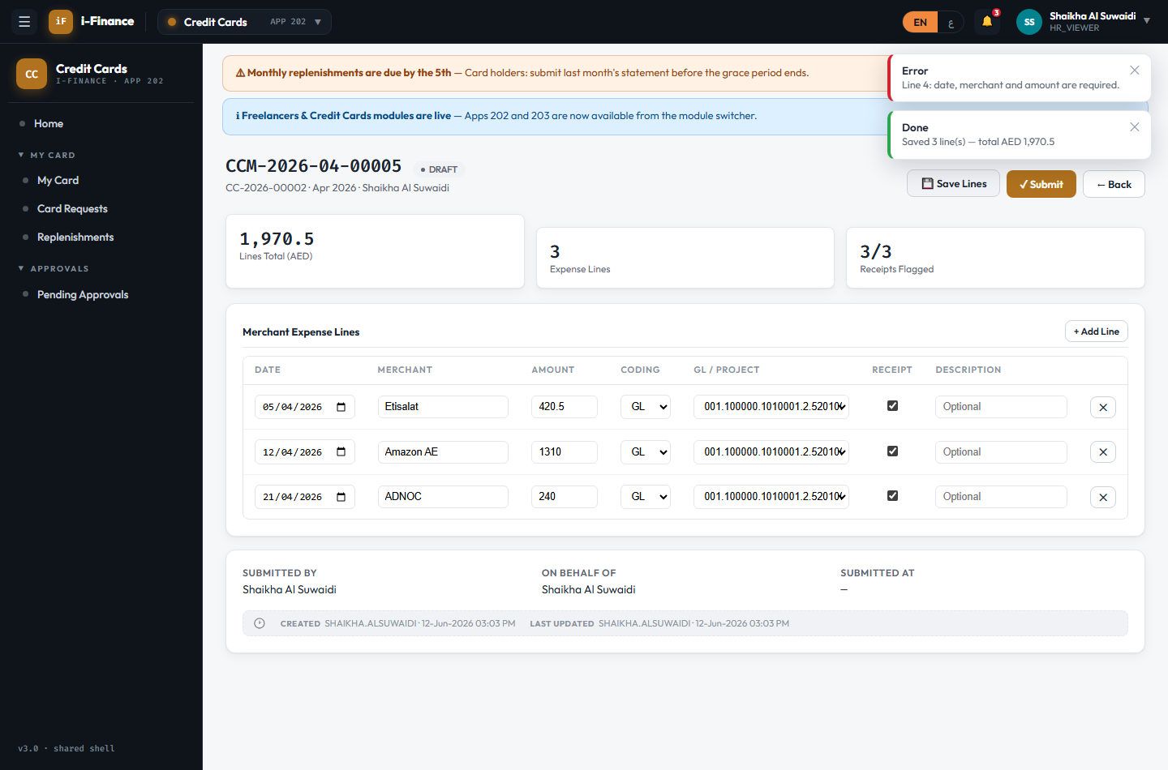
Evidence: CC-RPL-03.png

CC-RPL-04 — Send for approval
PASS · Submit · 10s
CCM-2026-04-00005 submitted by the holder; visible in the approvals queue (note: a phantom "Unsaved changes" marker appeared on a freshly loaded draft — saved first; minor UI defect to review)
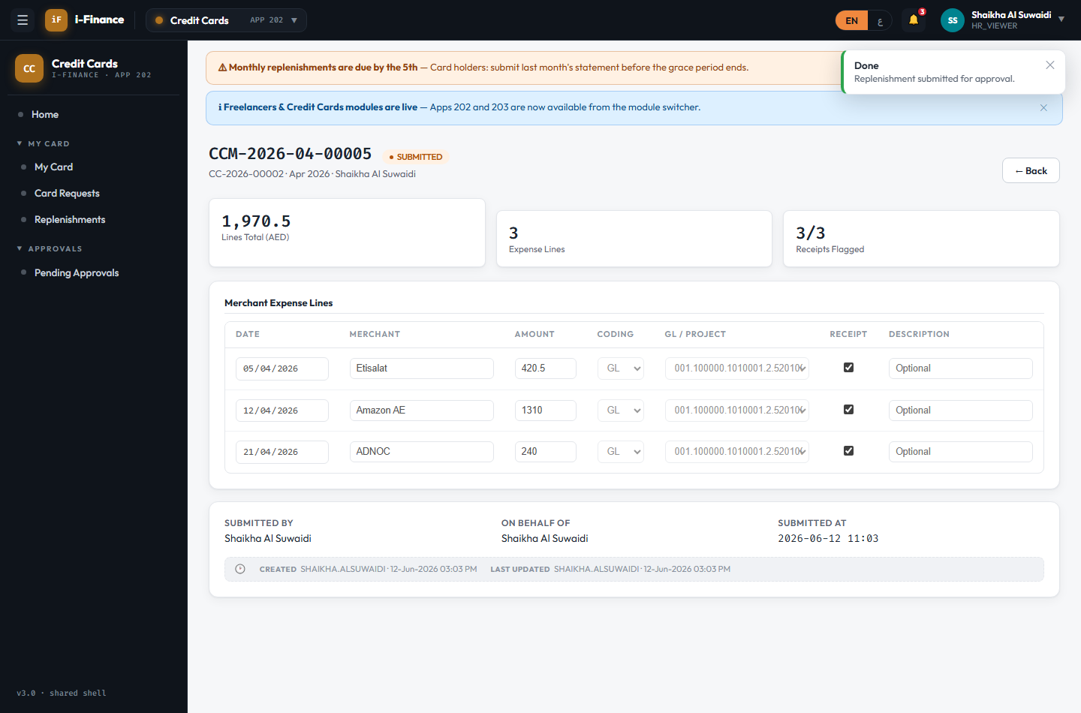
Evidence: CC-RPL-04.png

CC-RPL-05 — Proxy submits for the holder
PASS · Proxy · 12s
Proxy created for CC-2026-00002; proxy submitted CCM-2026-02-00006 on behalf of the holder; non-proxy blocked ("create blocked upstream")
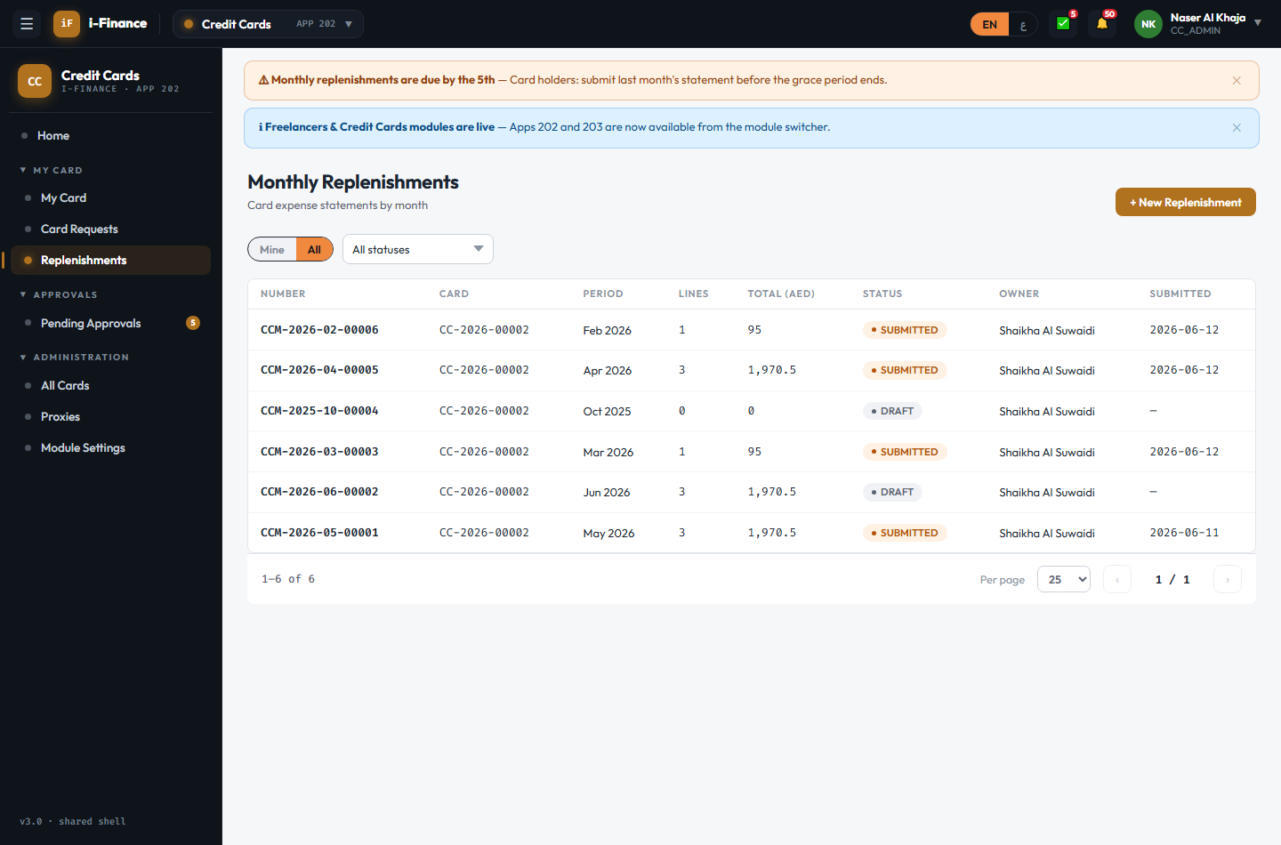
Evidence: CC-RPL-05.png

Approvals

CC-APR-01 — Pending list
PASS · Queue · 3s
5 items awaiting the approver (card requests: True, replenishments: True)
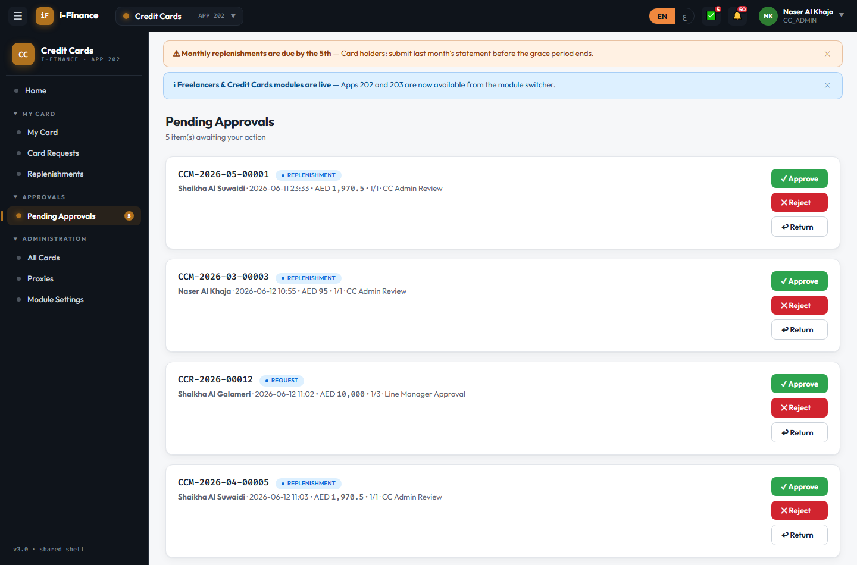
Evidence: CC-APR-01.png

CC-APR-02 — Approve needs a comment
PASS · Comment required · 6s
Empty comment blocked with "A comment is required."; CCM-2026-05-00001 stayed queued

Evidence: CC-APR-02.png

CC-APR-03 — Approved request applies
PASS · Lifecycle · 27s
INCREASE_LIMIT 20000 → 22000 fully approved; card limit updated + INCREASE history row; limit then restored to 20000 (ok)
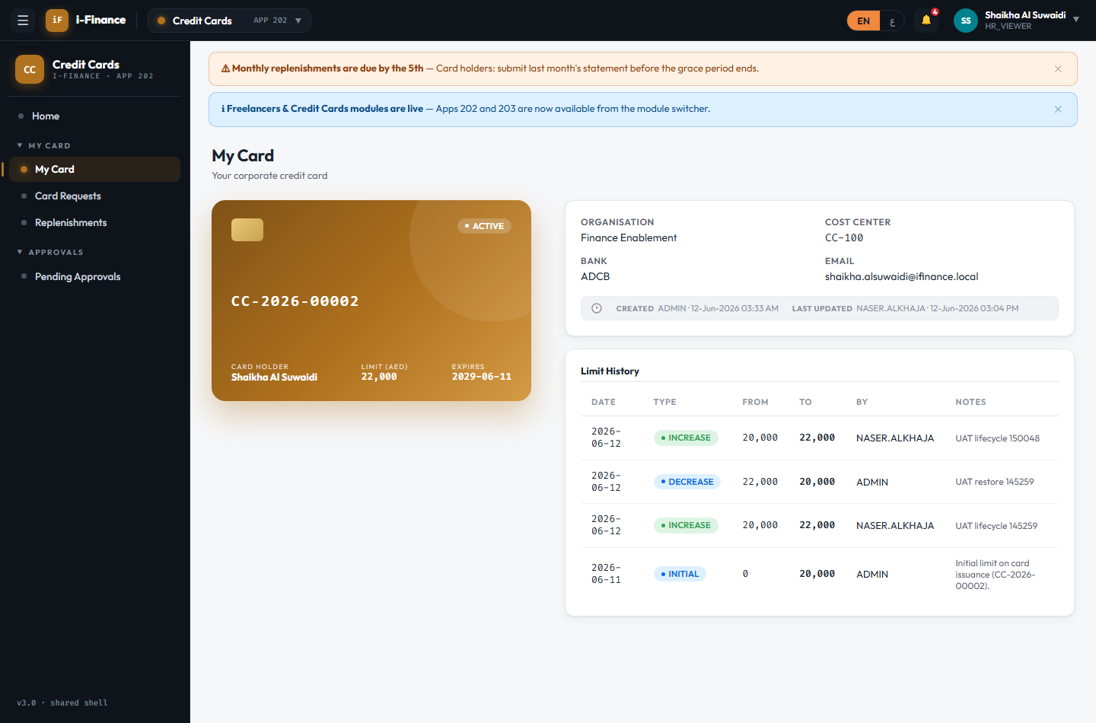
Evidence: CC-APR-03.png

Administration

CC-ADM-01 — Registry + search
PASS · All cards · 9s
4 cards org-wide; search "SHAIKHA" → 1; ACTIVE filter → 3; pending-op chips shown
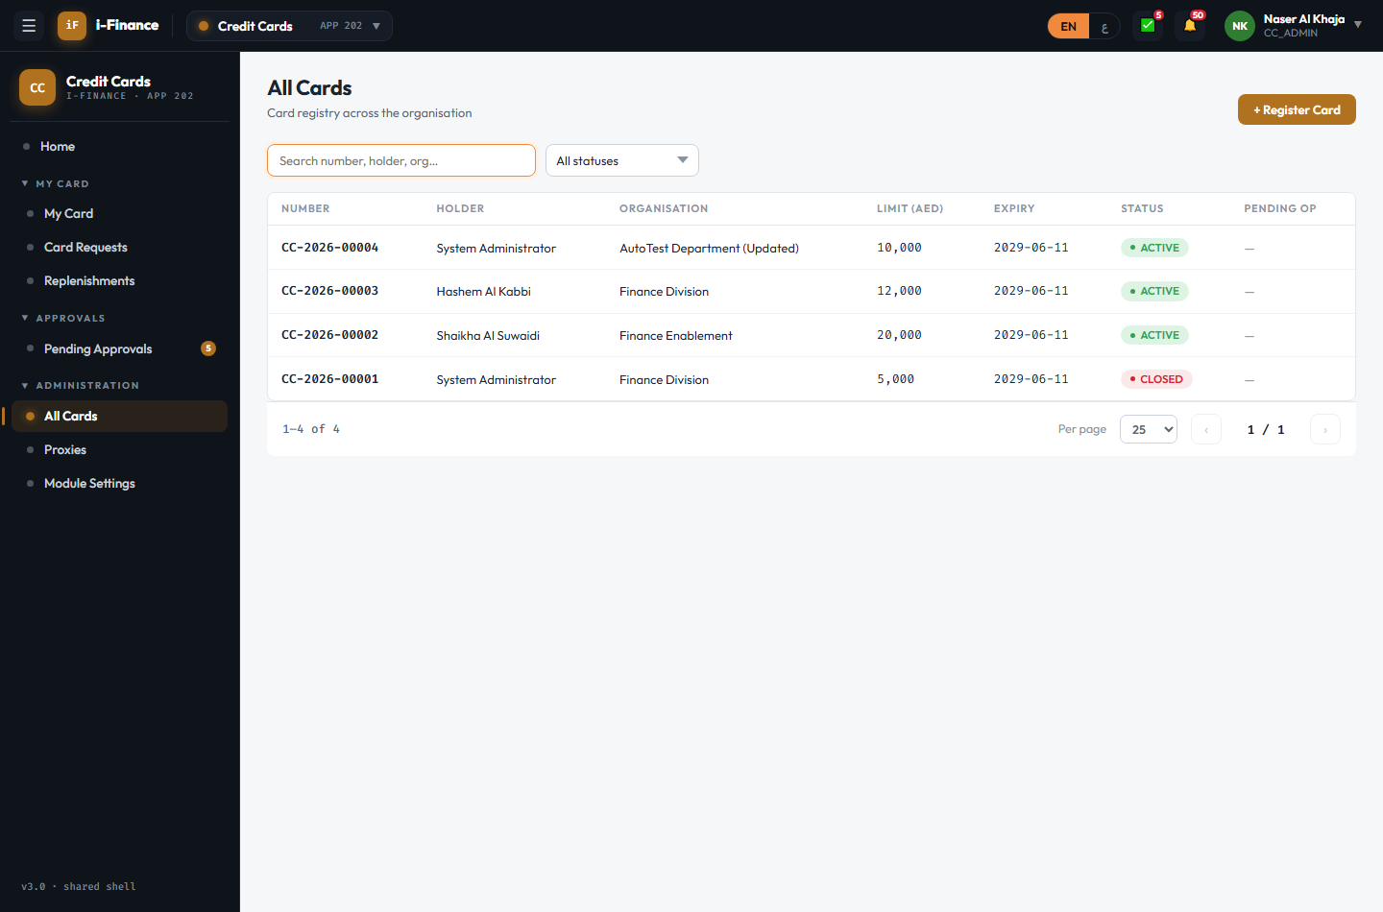
Evidence: CC-ADM-01.png

CC-ADM-02 — From approved NEW_CARD
PASS · Register card · 9s
Approved CCR-2026-00012 registered as CC-2026-00005 (ACTIVE, 10,000 AED, INITIAL history row) for SHAIKHA.GALAMERI
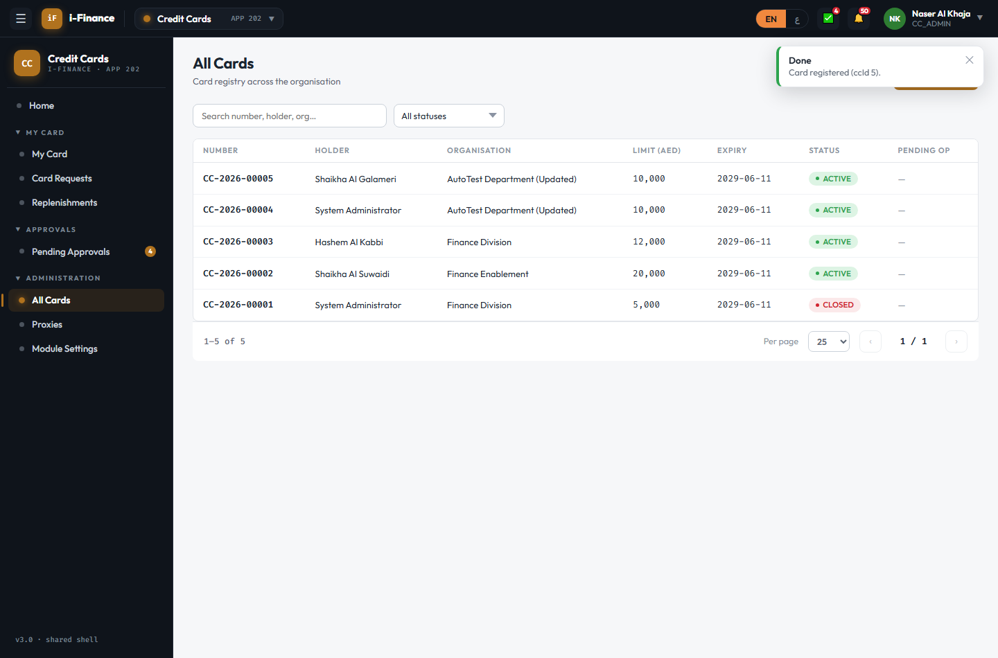
Evidence: CC-ADM-02.png

CC-ADM-03 — Manage proxies
PASS · Proxies · 10s
Proxy created on CC-2026-00005 then deactivated; submit rights removed
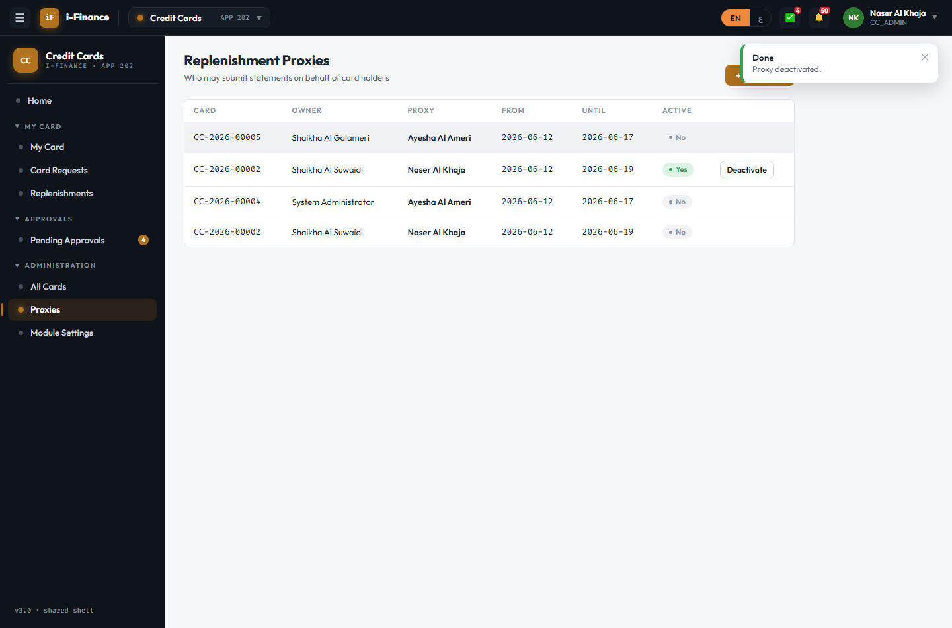
Evidence: CC-ADM-03.png

CC-ADM-04 — CC settings
PASS · Module settings · 12s
Setting 5 → 6 persisted across reload; restored to 5. Non-admins have no Module Settings nav (CC-ACC-03)
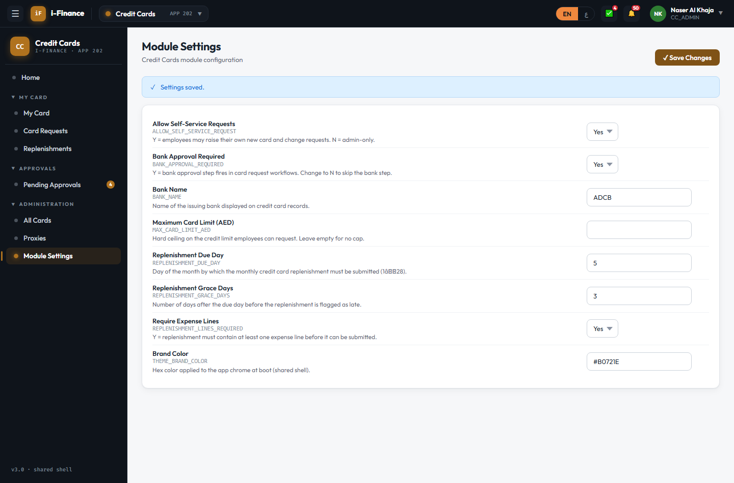
Evidence: CC-ADM-04.png

Shell & Language

CC-SHL-01 — Cross-module hop
PASS · Switcher · 8s
CC → FL → CC with no re-login; CC listed live (no "soon" badge)
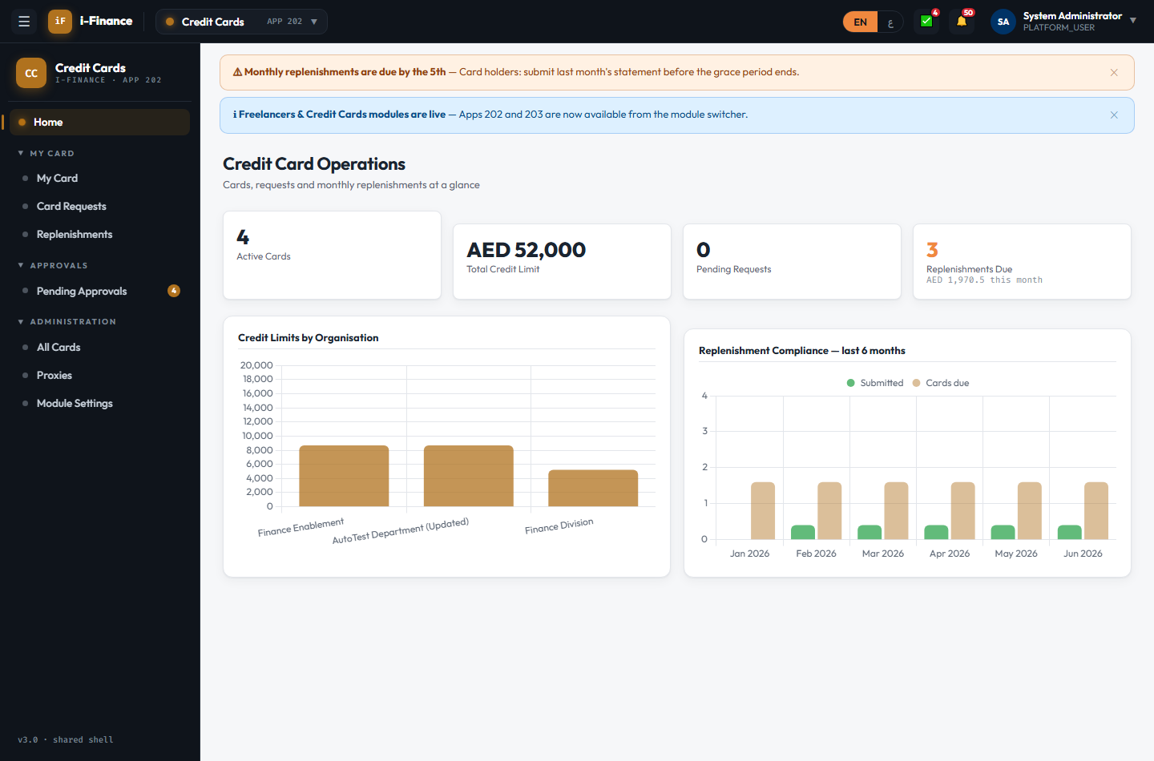
Evidence: CC-SHL-01.png

CC-SHL-02 — RTL pass
PASS · Arabic · 13s
RTL mirrored with Latin digits; charts re-rendered (2); card visual unaffected; detail OK
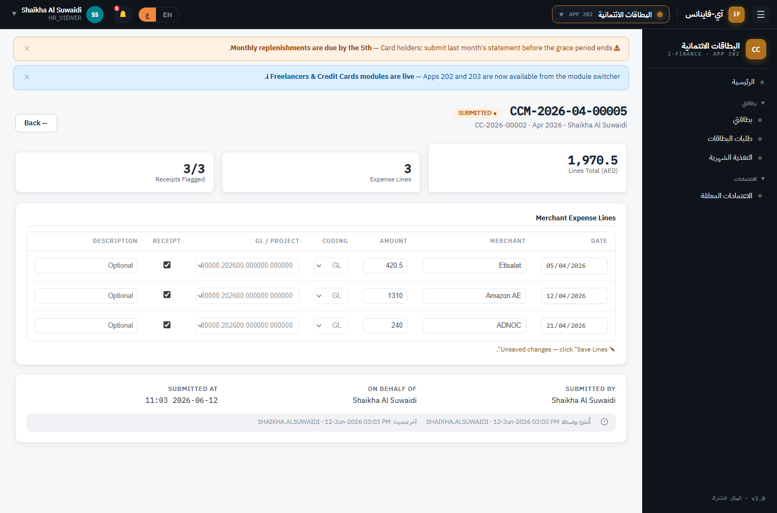
Evidence: CC-SHL-02.png

